|  |  |
| --- | --- |
| \\VFILERDPI\DPI-Home\OBRIENR2\My Documents\Downloads\PP logo.jpg |  |
| **COUNCIL ASSESSMENT REPORT**  HUNTER AND CENTRAL COAST PLANNING PANEL | |

|  |  |
| --- | --- |
| PANEL REFERENCE & DA NUMBER | PPSHCC-90 – DA/2294/2021 |
| PROPOSAL | Seniors housing  Independent living units in a residential flat building form |
| ADDRESS | 2A Maude Street, Belmont  Lot 202 DP 1236307 |
| APPLICANT | OTH Developments Pty Ltd |
| OWNER | Belmont 88 Pty Ltd |
| DA LODGEMENT DATE | 21 August 2021 |
| APPLICATION TYPE | Development Application (Integrated) |
| REGIONALLY SIGNIFICANT CRITERIA | Clause 2, Schedule 7 of the SRD SEPP: General Development over $30 million |
| CIV | $34,362,842 (excluding GST) |
| CLAUSE 4.6 REQUESTS | Clause 4.3 Height of buildings |
| KEY SEPP/LEP | *State Environmental Planning Policy (Planning Systems) 2021*  *State Environmental Planning Policy (Resilience and Hazards) 2021*  *State Environmental Planning Policy (Transport and Infrastructure) 2021*  *State Environmental Planning Policy (Building Sustainability Index: BASIX) 2004*  *State Environmental Planning Policy (SEPP) No. 65 – Design Quality of Residential Apartment Building*  *Lake Macquarie Local Environmental Plan 2014* |
| TOTAL & UNIQUE SUBMISSIONS  KEY ISSUES IN SUBMISSIONS | Notified 23 September 2021 – 29 October 2021  Council received 1 submission  Matters raised include:   * Visibility of plans online * Housing affordability * Urban design and site prominence |
| RECOMMENDATION | Approval |
| DRAFT CONDITIONS TO APPLICANT | YES |
| SCHEDULED MEETING DATE | 5 May 2022 |
| PREPARED BY | Geoffrey Keech, Senior Development Planner |
| DATE OF REPORT | 27 April 2022 |

**EXECUTIVE SUMMARY**

The development application seeks consent for the demolition of existing buildings, the construction of a three-storey residential flat building to be used for seniors housing, associated landscaping and stormwater infrastructure and a basement carpark at 2A Maude Street, Belmont.

The application is referred to the Hunter and Central Coast Regional Planning Panel (‘the Panel’) as the development is ‘*regionally significant development’*, pursuant to Clause (2) of Schedule 7 of *State Environmental Planning Policy (State and Regionally Significant Development) 2011* as the proposal is development with a CIV over $30 million.Under *State Environmental Planning Policy (Planning Systems) 2021,* seniors housing with a CIV over $20 million will be State Significant Development, however as this application was made but not determined before the policy was in force, under clause 2.21 of the SEPP the development is not State Significant Development.

The principle planning controls relevant to the proposal include:

* *State Environmental Planning Policy (Planning Systems) 2021*
* *State Environmental Planning Policy (Resilience and Hazards) 2021*
* *State Environmental Planning Policy (Transport and Infrastructure) 2021*
* *State Environmental Planning Policy (Building Sustainability Index: BASIX) 2004*
* *State Environmental Planning Policy No 65 – Design Quality of Residential Apartment Development*
* *Lake Macquarie Local Environmental Plan 2014*
* *Lake Macquarie Development Control Plan 2014*

The proposal is consistent with various provisions of the planning controls including:

* The development includes a building height variation which is considered to be appropriate for its location and be high-quality urban form.
* Traffic impact associated with the development is acceptable, and suitable public transport and pedestrian opportunities service the site.
* The development does not adversely impact any ecological features/attributes of the site, including flora and fauna.
* The development achieves appropriate acoustic privacy outcomes.
* The development includes a building height variation which is considered to be appropriate for its location and be high-quality urban form.
* The development achieves appropriate built form outcomes.
* The development is consistent with the zone objectives.

There were no concurrence requirements from agencies for the proposal.

The application is integrated development pursuant to Section 4.46 of the *Environmental Planning and Assessment Act 1979* with a referral to Water NSW and a review of plans by Subsidence Advisory NSW*.* Water NSW have not yet completed their review but indicated a timeframe of early May. Subsidence Advisory NSW have provided stamped approved plans without GTAs.

A referral to Ausgrid pursuant to *State Environmental Planning Policy (Transport and Infrastructure) 2021* was sent and raised only a minor objection which can be dealt with through condition of consent.

NSW Police were also provided the opportunity to comment but have not responded.

Jurisdictional prerequisites to the grant of consent imposed by the following controls have been satisfied including:

* Clause 4.6 of *State Environmental Planning Policy (Resilience and Hazards) 2021* for consideration of whether the land is contaminated;
* Clause 28(2)(a) of *State Environmental Planning Policy No 65 – Design Quality of Residential Apartment Development* in relation to advice of any design review panel have been satisfied; and
* Clause 2.48 of *State Environmental Planning Policy (Transport and Infrastructure) 2021* in relation to electricity substation, overhead easement and underground easement.

The proposal was reported to Council’s Design Review Panel, who gave endorsement to the development subject to minor amendments.

The application was exhibited from 23 September 2021 to 29 October 2021, with one submission received. This submission raised issues relating to visibility of application plans, housing affordability, and urban design. These issues are considered further in this report.

A kick-off briefing was held on 13 October 2021, introducing the site and early matters identified, including the integrated referral, height of building, and permissibility under the additional permitted use.

A briefing was held with the Panel on 8 December 2021 where key issues were discussed, including site interfaces, building height variation, contamination, stormwater management and gates.

A second briefing was held on 3 March 2022 to provide further detail around public interfaces to the north (Maude Street) and east (Miller Field), particularly with respect to noise, lighting, and impacts to the usability of the fields.

Following a detailed assessment of the proposal, the development is considered to be in the public interest and worthy of approval subject to conditions contained in Attachment A.

1. **THE SITE AND LOCALITY**
   1. **The site and locality**

The site is roughly square, being 93m wide and 90m deep, with a 37m by 22m handle to Glover Street. The total site area is 9,793m2 has two road frontages being Maude Street to the north, and Glover Street to the south. To the east the site fronts public sporting fields.

The site contains the former Belmont Sportsmans Club (“The Sporties”), associated carpark and part of the former Belmont Bowling Club green. Several mature trees line the southern entry and interface with 3 Glover Street. Existing vehicle access points to the site is from both Maude Street and Glover Street.

The site drains gently eastward toward the Belmont Wetlands.

The site is zoned RE2 – Private Recreation. An Additional Permitted Use (APU) applies to the site for the purpose of seniors housing.

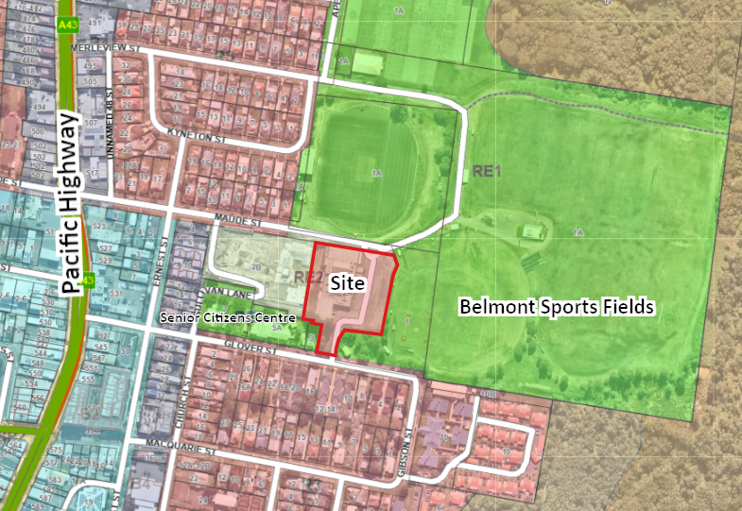

**Figure 1: Location map including zoning overlay**

To the north and east of the site is the Belmont sports fields, which are open grassed fields with single-storey amenities building, and a small grand stand to one of the ovals. Beyond this, is native bushland.

Immediately west of the site is a single-storey seniors housing - residential care facility, which is under construction. Further west is a single-storey senior citizens centre and childcare centre. A single residential dwelling sits south of the site adjacent the handle to Glover Street. Another seniors living development fronts the sports fields to the south.

Land to the south of Glover Street and north of Maude Street is zoned R3 Medium Density Residential. Several approvals have been issued for residential flat building development which are yet to be constructed. Several multi-dwelling housing developments exists, with a several more low density single dwellings.

West of the site is a buffer of B4 Mixed Use zone before reaching the B2 Local Centre zone which comprises the Belmont Town Centre. Belmont town centre provides a full suite of day to day facilities, including supermarkets, medical facilities, library, cafes and restaurants, boutique shops, and professional services.

Shops are located more toward the highway and within the town centre, with the lots further out still currently containing single dwellings and not reflective of the zoning.

Buses service Maude Street (200m) and Glover Street (90m), with additional options available on the highway (300m). The site is close to the centre of the Fernleigh Track and Fernleigh/Awabakal Shared Track network, a 30km north-south shared path providing access to Swansea, Belmont, Redhead, and connections into Newcastle.

1. **THE PROPOSAL AND BACKGROUND** 
   1. **The proposal**

The application seeks consent for the following:

* demolition of the Sporties building, car park and bowling green
* removal of two trees to facilitate new driveway access
* constructionof a 3-storey residential flat building for seniors living comprising:
  + 75 seniors living apartments
  + basement carparking for 83 spaces and 7 external parking spaces
  + swimming pool and associated landscaping.
* modifications to Council drainage infrastructure to remove a drainage pipe which runs beneath the existing building, and construct a new pipe through an existing easement and connection to the outflow point.

**Table 1: Development data**

|  |  |
| --- | --- |
| **Control** | **Proposal** |
| Site area | 9830m2 |
| Max height | 10.928m |
| Clause 4.6 Requests | Yes – 0.928m variation or 9.28% |
| No. of apartments | 75 |
| Landscaped area | Approx. 1890m2 |
| Car parking spaces | 83 basement spaces and 7 external parking spaces |
| Setbacks | Maude Street / North - 5.58m |
| East   * 5.7m-9.65m (terraces) * 7.81m-11.75m (balconies) * 9m-13.7m (walls) |
| West   * 7.4m (terraces / balconies) * 10.6m (wall) |
| Glover Street (South) - 48.3m |

* 1. **Background**

A pre-lodgement meeting was held prior to the lodgement of the application on 22 June 2021 where various issues were discussed. A summary of the key issues and how they have been addressed by the proposal is outlined below:

* LEP amendment

Completion of the LEP amendment for an Additional Permitted Use to permit seniors housing on the site occurred prior to the lodgement of the application.

* Urban Design

The application undertook a separate SEPP65 DRP pre-lodgement meeting. Matters relating to this are discussed under SEPP65 in this report.

* Layout and public interface

The design was amended to a “U” shape from the original linear form, resulting in an overall shortening of the length. Articulation and materials were introduced.

* Parking arrangements

The basement car park was reshaped to a more logical aisle arrangement. Overall parking numbers were considered suitable.

* Flood levels and stormwater drainage

Floor levels and garage entry have been set appropriately. The stormwater pipes running through the site will be realigned. Overland flow path is kept free of buildings.

* Contamination

A contamination assessment was carried out for this application.

* Accessibility

An access report has been provided and continuous paths of travel included between the apartments to recreation areas and public transport.

The development application was lodged on 21 August 2021. A chronology of the application since lodgement is outlined below including the Panel’s involvement with the application:

**Table 2: Chronology of the DA**

|  |  |
| --- | --- |
| **Date** | **Event** |
| 21 August 2021 | Lodgement of application |
| 23 September 2021 | Exhibition of the application |
| 23 September 2021 | DA referred to external agencies |
| 13 October 2021 | Panel kick-off briefing |
| 21 October 2021 | Request for information from Council to applicant |
| 5 November 2021 | Request for information from Council to applicant |
| 16 November 2021 | Amended documents lodged   * Contamination report * Aboriginal cultural heritage report |
| 2 December 2021 | Amended plans lodged   * Respond to SEPP65 comments * Erosion and sediment control plan |
| 8 December 2021 | Panel briefing |
| 17 December 2021 | Request for information from Council to applicant |
| 8 February 2022 | Amended documents submitted   * Architectural plans * Waste management * Acoustic advice * Engineering plans |
| 18 February 2022 | Amended documents submitted   * Engineering plans |
| 3 March 2022 | Panel supplementary briefing |
| 9 March 2022 | Request for information from Council to applicant |
| 15 March 2022 | Amended documents submitted   * Geotechnical report |
| 17 March 2022 | Request for information from Council to applicant |
| 1 April 2022 | Amended documents submitted   * Engineering plans |

* 1. **Site history**

The site was at one time in Council ownership, forming part of the larger sporting precinct. The club (including the adjacent bowling club site) was sold in 2001 to the Sportsmans Club, and subsequently subdivided into two lots. Due to the previous Council ownership, several utilities and services are located inappropriately for a site with separate ownership. A fire service pipe servicing the site is located within the road reserve, and a stormwater pipe runs through the site under the existing building. Other than the former bowling club site, the surrounding land is Council-owned.

The adjacent bowling club site has an approved seniors housing (residential care facility), owned by an unrelated operator, which is currently under construction. Works related to this development are expected to include the installation of a stormwater pipe through an existing easement on the subject site. The two developments have coordinated with respect to the stormwater design.

1. **STATUTORY CONSIDERATIONS**

When determining a development application, the consent authority must take into consideration the matters outlined in Section 4.15(1) of the *Environmental Planning and Assessment Act 1979* (‘EP&A Act’).

These matters as are of relevance to the development application include the following:

1. *the provisions of any environmental planning instrument, proposed instrument, development control plan, planning agreement and the regulations*
2. *the likely impacts of that development, including environmental impacts on both the natural and built environments, and social and economic impacts in the locality,*
3. *the suitability of the site for the development,*
4. *any submissions made in accordance with this Act or the regulations,*
5. *the public interest.*

These matters are further considered below.

The proposal is integrated development (which are considered further in this report)

* 1. **Section 4.15(1)(a)(i) - Provisions of Environmental Planning Instruments**

The following Environmental Planning Instruments are relevant to this application:

* *State Environmental Planning Policy (Planning Systems) 2021*
* *State Environmental Planning Policy (Resilience and Hazards) 2021*
* *State Environmental Planning Policy (Transport and Infrastructure) 2021*
* *State Environmental Planning Policy (Building Sustainability Index: BASIX) 2004*
* *State Environmental Planning Policy (SEPP) No. 65 – Design Quality of Residential Apartment Building*
* *Lake Macquarie Local Environmental Plan 2014*

A summary of the key matters for consideration arising from these State Environmental Planning Policies are outlined in Table 3 and considered in more detail below.

**Table 3: Summary of Applicable State Environmental Planning Policies**

|  |  |  |
| --- | --- | --- |
| **EPI** | **Matters for Consideration** | **Comply** |
| Planning Systems SEPP 2021 | Clause 2.19 declares the proposal as regionally significant development pursuant to Clause 2 of Schedule 6. | Y |
| Resilience and Hazards SEPP 2021 | Clause 4.6 - Contamination and remediation has been considered in the Contamination Report and the proposal is satisfactory subject to conditions.  Minor contamination was found and will be remediated. | Y |
| Transport and Infrastructure SEPP 2021 | Clause 2.48 - Determination of development applications—other development – electricity transmission  Ausgrid have an electricity easement and substation located on the property. Ausgrid have reviewed the application and indicated they had no issues subject to suitable tree selection near the overhead wires. The proposal is satisfactory subject to conditions | Y |
| BASIX SEPP | A compliant BASIX certificate was lodged with the application. | Y |
| SEPP 65 | Clause 28 Determination of Applications  The proposal is consistent with the design quality principles outlined in the apartment design guide and the Apartment Design Guide.  Council’s DRP considered the application and were generally satisfied with the development subject to some minor changes. These changes have been made to the satisfaction of Council. | Y |

**State Environmental Planning Policy (Planning Systems) 2021**

The application is regionally significant development under Part 2.4 Regionally significant development and Schedule 6 – clause 2 of the SEPP due to the value of the development exceeding $30 million.

Accordingly, the Hunter and Central Coast Regional Planning Panel (RPP) is the consent authority for the application.

Under *State Environmental Planning Policy (Planning Systems) 2021,* seniors housing with a CIV over $20 million will be State Significant Development, however as this application was made but not determined before the policy was in force, under clause 2.21 of the SEPP the development is not State Significant Development.

**State Environmental Planning Policy (Resilience and Hazards) 2021**

The provisions of *State Environmental Planning Policy (Resilience and Hazards) 2021* have been considered in the assessment of the development application. Clause 4.6 of the SEPP requires consent authorities to consider whether the land is contaminated, and if the land is contaminated, it is satisfied the land is suitable in its contaminated state (or will be suitable, after remediation) for the purpose for which the development is proposed to be carried out.

In order to consider these provisions, a contamination assessment has been prepared for the site. The assessment consisted of a review of a previous preliminary site investigation (undertaken for the rezoning), subsurface investigations, groundwater well installation, sampling and testing of soil and groundwater.

The investigation also reviewed the site history and outlined the Belmont ‘Sporties’ club was present at the site from at least the mid-1950s, with the adjacent sporting fields present around a decade earlier. The site previously comprised several smaller lots, owned by private residents and Lake Macquarie City Council. No NSW EPA contaminated land notices or licensed operations were noted for the site.

A 2800L aboveground LPG tank was previously located at the site, to the north of the existing ‘Sporties’ building. Hazardous building material assessment indicated the presence of some asbestos-containing material, synthetic mineral fibres and possible polychlorinated biphenyl-containing light fittings in the structure. Further potential sources of contamination included oil where vehicles were maintained, potential for asbestos in car park and site fill areas, and contamination from cars in the car park.

Sampling and testing conducted for this report found marginal exceedances of thresholds in six soil samples and three ground water samples, comprising four contaminants. The majority of surface soils are expected to be removed from site as part of the development. The report noted the metals found in the groundwater are likely attributable to background levels rather than contamination.

The report concluded the site can be made suitable for the proposed residential accommodation, subject to conditions of consent. This conclusion was based on the proposed works, which include demolition of the buildings and the excavation of the site for the basement removing fill materials (if present) as well as shallow residual soils. This will effectively mitigate the potential health and ecological risks associated with these materials for future use of the site. The proposal is considered to be consistent with the SEPP subject to imposition of relevant conditions of consent in relation to remediation works during construction on any consent granted.

**State Environmental Planning Policy (Transport and Infrastructure) 2021**

The provisions of *State Environmental Planning Policy (Transport and Infrastructure) 2021* have been considered in the assessment of this application. Clause 2.48 requires a consent authority to give written notice to an electricity supply authority whose assets are impacted by the development. This development site includes easements for overhead electricity, underground electricity and an electrical substation. Ausgrid are the agency responsible for these assets and easements.

Ausgrid were notified of the application and provided a response which supported the development and included information relating to safe work practices around powerlines.

* The design of the building does not encroach into safety margins for the overhead easement.
* Asset location was recommended in addition to Dial Before You Dig searches.
* 24 hour access is required to the kiosk and the site fencing must ensure the kiosk remains outside the work site.
* Planting of suitable sized trees near the powerlines will reduce ongoing maintenance.

Clause 2.137 permits work to the stormwater management system on the land. The application requires alterations to the stormwater management system on Council-owned land which include realignment of the stormwater pipe within Maude Street and a new pipe route through the south end of the sporting fields. This application does not include a request for consent for these works within the sporting fields, which may be undertaken without consent under Clause 2.136. The route and environmental consequences are discussed under the stormwater section.

**State Environmental Planning Policy (Building Sustainability Index: BASIX) 2004**

*State Environmental Planning Policy – Building Sustainability Index BASIX– 2004* (‘BASIX SEPP’) applies to the development. The objectives of this Policy are to ensure the performance of the development satisfies the requirements to achieve water and thermal comfort standards that will promote a more sustainable development.

The application is accompanied by BASIX Certificate No.1234427M prepared by Ecological Design Pty Ltd dated 03 September 2021 committing to environmentally sustainable measures. The Certificate demonstrates the proposed development satisfies the relevant water, thermal and energy commitments as required by the BASIX SEPP. The proposal is consistent with the BASIX SEPP subject to the recommended conditions of consent.

**State Environmental Planning Policy No. 65 – Design Quality of Residential Apartment Development**

The provisions of *State Environmental Planning Policy No. 65 – Design Quality of Residential Apartment Development* have been considered in the assessment of this application.

The building comprises three stories and more than four dwellings. In accordance with clause 28 of the SEPP, the application was referred to Council’s DRP following lodgement on 13 October 2021. The development was also presented to the DRP prior to lodgement.

The advice provided by the DRP and the applicant’s responses are summarised below and incorporates both meetings:

* Distance from the lift cores to the northern apartments.

Resting points were recommended and have been provided.

* The reception and communal areas were noted as a positive outcome and entry to the building.
* Basement car parking arrangement was considered easy for wayfinding. A space to move cars to when accessing the storage cages was recommended.

The car wash bay is proposed for this purpose.

* Space was not provided in the car park for motorised scooters or e-bikes.

This has now been provided in a storage cage at the southern entry.

* The central courtyard was considered constrained and dominated by structures.

This has been reconfigured to relocate the gym into the main building and remove the structure north of the pool in favour of landscaping.

* The panel suggested a reduction in the number of apartments in order to accommodate the gym and scooter storage.

Alternative solutions have been proposed and the number of apartments has not been required to be reduced.

* The panel were supportive of the proposed sustainability initiatives, which included solar panels and battery back up, and water harvesting and re-use.
* Provisions will be allowed for electric vehicle charging, inclusive of two dedicated charging spaces at the outset.
* Balconies/terraces facing the internal courtyard have been redesigned to allow for greater deep soil planting.
* Access from the ground floor apartments to the external footpath was supported.
* The panel noted the opportunity to take a different landscape approach to the east and western interfaces, given the differences in adjoining uses.

The landscape plan has been proposed in a way which allows for flexibility in the selection of plants applied to these areas which can achieve a point of difference on either side of the development. This would occur at detailed design, as the planting schedule is not prescriptive regarding species location.

* The Maude Street pedestrian gate has been redesigned to be less imposing and defensive.
* The waste storage off Glover Street has been rotated to minimize impact to the street.
* Additional seating opportunities have been provided in the south-western lawn.
* Footpath around a tree to be retained has been addressed to mitigate desire lines.
* The number of access points to the building has been reduced slightly for security.
* The apartment mix was considered appropriate.
* The facades and material selection was considered attractive.

The panel indicated a subsequent review was not necessary and afforded the Council assessing officer discretion as to whether the matters raised were addressed satisfactorily. The revised plans have been reviewed and Council is satisfied the matters have been suitably addressed.

An assessment of the development against the Apartment Design Guide (ADG) is detailed in Attachment B.

Adequate regard for the design quality principles and the objectives of the Apartment Design Guide has been demonstrated in the design. The design review panel have considered the design quality principles and provided recommendations which have been addressed in the amended plans.

**Lake Macquarie Local Environmental Plan 2014**

The relevant local environmental plan applying to the site is the *Lake Macquarie Local Environmental Plan 2014* (*LMLEP 2014*).

The site is zoned RE2 Private Recreation. The site is also subject to an APU (Belmont Area 1) which permits seniors housing with development consent.

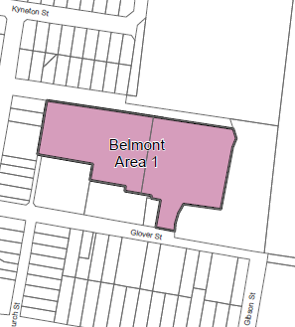

**Figure 2: APU map**

The proposal is considered to be consistent with the zone objectives as follows:

* The development provides a compatible use of the land within a recreation setting.
* The development protects the natural environment and environmental qualities of land.
* The development complements its location and minimises environmental impacts.

The LEP also contains controls relating to development standards, miscellaneous provisions and local provisions. The controls relevant to the proposal are considered in Table 4 below.

**Table 4: Consideration of the LEP controls**

|  |  |  |  |
| --- | --- | --- | --- |
| **Control** | **Requirement** | **Proposal** | **Comply** |
| Height of buildings  (cl 4.3) | 10 metres | 10.928m, which equates to a 0.928m or 9.28 percent variation.  Refer to discussion under Key Matters. | No  However acceptable through cl4.6 |
| Heritage conversation  (cl 5.10) | Consideration must be given to the effect of the proposed development on heritage significance of Aboriginal objects or places.  Notification must be given to local Aboriginal communities for at least 28 days. | The site is not within the Aboriginal Sensitive Landscape, however there is an AHIMS record located within 50m of the site. The heritage site is in a location which is unlikely to be impacted by the works.  An Aboriginal heritage report was submitted and referred to local Aboriginal groups for 28 days. No objections were received and the development is considered able to proceed with caution. Conditions of consent have been proposed. |  |
| Acid sulphate soils  (cl 7.1) | Class 3  Works more than 1 metre below the natural ground surface.  Works by which the watertable is likely to be lowered more than 1 metre below the natural ground surface.  Development consent must not be granted under this clause for the carrying out of works unless an acid sulfate soils management plan has been prepared for the proposed works in accordance with the Acid Sulfate Soils Manual and has been provided to the consent authority | An contamination report has been submitted with the application and identified potential acid sulfate soils below 1m.  An acid sulfate soil management plan will be submitted prior to determination of the application. | Yes |
| Earthworks  (cl 7.2) | Consideration must be given to:   1. impacts on drainage patterns, soil stability, or environmentally sensitive areas. 2. the effect on the development, including on amenity of adjoining properties. 3. the source and quality of the fill to be excavated. 4. the likelihood of disturbing relics 5. measures to avoid, minimise or mitigate impacts. | The application proposes excavation up to a maximum of 3m of cut and 1m of fill across the building footprint.  Retaining walls are proposed along the boundary of the sports fields site which generally have heights no higher than 0.6 metres.  Appropriate stormwater management has been included to ensure the works do not have an impact on drainage patterns.  Council’s Development Engineer has reviewed and is satisfied with the proposed earthworks.  Conditions of consent can be imposed to ensure only quality fill is imported and earthworks works are undertaken appropriately. | Yes |
| Essential services  (cl. 7.21) | Development consent must not be granted unless the consent authority is satisfied the following services are available to the development:  (a) the supply of water,  (b) the supply of electricity,  (c) the disposal and management of sewage,  (d) stormwater drainage or on-site conservation,  (e) suitable vehicular access. | The site has adequate availability of water, sewer, electricity, and telecommunications to service the development.  The development has incorporated appropriate stormwater management.  Suitable vehicle access is provided to the development. | Yes |

The proposal is considered to be generally consistent with the LEP.

* 1. **Section 4.15 (1)(a)(ii) - Provisions of any Proposed Instruments**

There are several proposed instruments which have been the subject of public consultation under the EP&A Act, and which may be relevant to the proposal, including the following:

* *Draft State Environmental Planning Policy (Housing) 2021*
* *Proposed BASIX higher standards*
* *Review of clause 4.6 of the Standard Instrument LEP*
* *Environmental Planning and Assessment Regulation 2021*

These proposed instruments are considered below.

**Draft State Environmental Planning Policy (Housing) 2021**

The development would have been permissible with consent in the RE2 Private Recreation zone under the new SEPP if the club had still been registered. Permissibility therefore remains via the additional permitted use and the SEPP would be used for benchmarking only.

The definition of *Seniors* is increased from 55 years of age to 60 years of age.

Benchmarking of the site against the revised provisions is included in Attachment C

**Proposed BASIX higher standards**

Apartment buildings up to five stories are not included in the draft changes.

**Review of clause 4.6 of the Standard Instrument LEP**

An Explanation of Intended Effect was exhibited from 31 March until 12 May 2021. The proposed changes seek to revise the test for determining if a contravention of the development standard is appropriate. In particular, the suggested test would include demonstration the contravention would result in an improved environmental outcome compared to if the standard was not contravened.

The application would achieve the proposed test.

**Environmental Planning and Assessment Regulation 2021**

The Regulation had not commenced at the time of lodgement and savings provisions under Schedule 6 clause 3 apply. There are no matters relevant to this application that are substantially different from the 2000 Regulation.

Under *State Environmental Planning Policy (Planning Systems) 2021,* seniors housing with a CIV over $20 million will be State Significant Development, however as this application was made but not determined before the policy was in force, under clause 2.21 of the SEPP the development is not State Significant Development.

* 1. **Section 4.15(1)(a)(iii) - Provisions of any Development Control Plan**

The *Lake Macquarie Development Control Plan 2014* (*LMDCP 2014*) is relevant to the application. In particular, Part 6 Development in Recreation and Tourist Zones.

**Table 5: Consideration of the DCP**

| **Control** | **Discussion** | **Comply** |
| --- | --- | --- |
| Stormwater management | A stormwater plan accompanies the application and is considered suitable by Council’s Development Engineer.  An existing Council stormwater pipe runs diagonally through the site, as a legacy from the site’s previous Council ownership. An easement to drain water in favour of Council runs east-west through the site, however the pipe is not located within the easement. A stormwater pipe servicing Maude Street also enters the site at the north end. Both of these pipes are to be removed by these works.  The pipe servicing Maude Street will be relocated to be wholly within the road reserve. The pipe running diagonally through the site will be realigned to the existing easement.  A new connection to the outflow in the sporting precinct will also be required. This work does not form part of this consent, however consideration has been given to the impacts of the route, which are considered acceptable. The portion of the work within the sporting precinct will be subject to a Review of Environmental Factors approval under SEPP (Transport and Infrastructure), as it will be a Council-owned pipe within Council land.  A development was approved in 2021 at 2B Maude Street for a seniors housing (residential care facility). The development required the augmentation of the downstream stormwater capacity, and the resulting design provided for a new stormwater pipe through the easement as described above. This development will utilise the same design.  Each development will require these works independently of the other and a condition of consent has been drafted to ensure delivery of the pipes as part of current development in the event they have not been delivered already by the adjoining development. As the existing pipes receive stormwater from upstream, provision for the new outflow should be provided prior to the disconnection of the existing pipe. | Y |
| Preservation of trees and vegetation | Two trees are proposed for removal to facilitate the driveway access.  Six mature trees are proposed for retention within the ‘handle’ access from Glover Street. A further eight trees are located on adjacent lots in the same vicinity which may be impacted by the works due to their structural root zones and/or tree protection zones extending into the site.  An arborist report was submitted with the application. The report concluded the retention of the nominated 14 trees was achievable, and provided recommendations for their management and protection during construction works. Conditions of consent have been proposed which address the recommendations of the report. | Y |
| Social impact | A social impact assessment was submitted with the application and reviewed by Council’s Social Planner. While the officer noted the proposal was unlikely to result in any significant negative social impacts, several items were raised to be addressed further.  For detailed consideration of this matter, refer to assessment under Key Matters. | Y |
| Landscape / streetscape / building bulk and scale | A landscape plan prepared by a qualified landscape architect was submitted. The proposed works to Maude Street were supported. Street tree planting to Glover Street is possible and can be a condition of consent.  Building bulk is minimised from Glover Street by the deep setback. Bulk and scale is addressed through articulation of the facades, variation in material selection and the provision of suitable landscaping to the perimeter of the site.  For detailed consideration of this matter, refer to assessment under Key Matters. | Y |
| Side and rear fences | Side and rear fences are a masonry plinth and pillar style with palisade infill panels. The plinth doubles as a retaining wall to take up height changes between the site and adjacent land.  The height of the proposed fence will be 2.1m total (inclusive of 0.6m plinth and 1.5m pier with palisade infill) and is similar to the existing fence around the site.  The fence will provide visual permeability for casual surveillance, balanced against access control for site security.  The fence is considered to have a good aesthetic for the public interface. A solid acoustic fence is considered to have a lesser aesthetic, and would be considered a poor outcome. | Y |
| Street trees | Due to the verge width, determined by the overall road reserve width, street trees in Maude Street are not achievable.  One street tree is achievable in Glover Street, and a condition of consent has been proposed to address this. | Y |

The development is subject to 7.11 development contributions under the *Lake Macquarie City Council S7.11 Development Contributions Plan Belmont Contributions Catchment 2021*. This contribution plan has been considered and draft consent conditions have been included which applies contributions for a 75-dwelling seniors housing development.

* 1. **Section 4.15(1)(a)(iiia) – Planning agreements under Section 7.4 of the EP&A Act**

There have been no planning agreements entered into and there are no draft planning agreements being proposed for the site.

* 1. **Section 4.15(1)(a)(iv) - Provisions of Regulations**

Clause 92(1) of the Regulation contains matters that must be taken into consideration by a consent authority in determining a development application, comprising the following:

The application proposes demolition, and conditions will be imposed requiring these works to be undertaken in accordance with AS 2601.

* 1. **Section 4.15(1)(b) - Likely Impacts of Development**

The likely impacts of that development, including environmental impacts on both the natural and built environments, and social and economic impacts have been detailed throughout the assessment report.

* 1. **Section 4.15(1)(c) - Suitability of the site**

It is considered the development is suitable for the site, as detailed in this report.

Further the suitability of the site for seniors housing was considered through the rezoning proposal which resulted in the APU. This application gives effect to the suitability established by the planning proposal process.

* 1. **Section 4.15(1)(d) - Public Submissions**

These submissions are considered in Section 5 of this report.

* 1. **Section 4.15(1)(e) - Public interest**

The development is considered to achieve balanced and orderly outcomes, and is in the public interest. The development has demonstrated no significant amenity impacts will arise now or in the future, subject to the imposition and compliance with recommended conditions of consent.

1. **REFERRALS AND SUBMISSIONS** 
   1. **Agency Referrals and Concurrence**

The development application has been referred to various agencies for as required by the EP&A Act and outlined below in Table 6.

There are no outstanding issues arising from these concurrence and referral requirements subject to the imposition of the recommended conditions of consent being imposed.

**Table 6: Concurrence and referrals to agencies**

|  |  |  |  |
| --- | --- | --- | --- |
| **Agency** | **Concurrence/**  **referral trigger** | **Comments** | **Resolved** |
| Concurrence Requirements (s4.13 of EP&A Act) | | | |
| Nil | | | |
| Integrated development (S 4.46 of the EP&A Act) | | | |
| Subsidence Advisory NSW | S22 – *Coal Mine Subsidence Compensation Act 2017*  Alter or erect improvements within a mine subsidence district. | The development obtained Subsidence Advisory NSW endorsed plans and submitted them with the application. General Terms of Approval were not required for this development. | Y |
| Water NSW | S89-91 – *Water Management Act 2000*  Water use approval, water management work approval or activity approval under Part 3 of Chapter 3 | The basement carpark will intercept the water table and require dewatering during construction.  General Terms of Approval are being sought from Water NSW and will be obtained prior to determination. | TBA |
| Referral / consultation agencies | | | |
| Electricity supply authority | Transport and Infrastructure SEPP  Clause 2.48 - Determination of development applications—other development) – electricity transmission | An easement containing HV and LV electricity is present at the front of the site. Buildings are clear of the assets and easement.  Works are also in the vicinity of underground electrical assets. These should be located prior to commencing work.  24hr access is required to the electrical kiosk on site. Site fencing must exclude the kiosk.  A small tree selection should be made for any planting near to overhead powerlines. | Yes  (conditions) |
| Design Review Panel | Cl 28(2)(a) – SEPP 65  Advice of the DRP. | The advice of the DRP has been considered in the proposal and is further discussed in the SEPP 65 assessment. | Yes |

* 1. **Council referrals**

The development application has been referred to various Council officers for technical review as outlined Table 7.

**Table 7: Consideration of Council referrals**

|  |  |  |
| --- | --- | --- |
| **Officer** | **Comments** | **Resolved** |
| Development - Engineering | The officer has reviewed and is supportive of the development, particularly acknowledging the development has included appropriate stormwater management which matches the approval for the adjacent development.  Engineering comments have been included in the draft conditions of consent. | Yes |
| Development - Building | No issues raised. | Yes |
| Development - landscape | Landscaping documentation has been submitted with the application.  Concerns were initially identified by Council’s Landscape Architect regarding the streetscape presentation to Maude Street, and hardstand and amenity for the pool area.  Revised landscaping documentation has been submitted with the application. The officer has reviewed and supported the revised outcomes. The plans are to be included in the recommended conditions of consent. | Yes |
| Development – Erosion and Sediment Control | An appropriate erosion and sediment control plan has been submitted and conditions of consent recommended. | Yes |
| Assets - Traffic | Council’s Traffic Engineering Officer reviewed the proposal and agreed it was not likely to adversely impact local traffic.  A footpath along Maude Street was recommended. | Yes |
| Assets - Driveway | No issues raised. | Yes |
| Assets - Drainage | The pipe servicing Maude Street is to be relocated outside of the site. The officer is supportive of this outcome. | Yes |
| Environmental Management - Food | No issues raised – conditions recommended. | Yes |
| Environmental Management - noise / contamination | Council’s Environmental Manager Officer has reviewed and is supportive of the development subject to conditions regarding compliance with acoustic reporting, and remediation action plan. | Yes |
| Waste | The development initially proposed Insinkerators, but these have been changed out for private green waste collection.  The officer is satisfied with this amended outcome. | Yes |
| Community Partnerships – community land | Community Partnerships supplied details of the desired future outcomes for Maude Street north of the development. These have been incorporated into the plans.  Management of stormwater should be piped through to the outflow. Release of water onto the sports fields or the construction of new swales was not supported. These comments relate to the offsite stormwater works subject to assessment under Transport and Infrastructure SEPP. Plans showing the proposed route should be annotated to clearly delineate which parts are approved by this consent. | Yes |
| Community Partnerships – Social impact | A construction management plan has been recommended to manage impacts to adjoining community facilities.  An operational management plan was recommended as a condition, with minimum matters to be considered including:   * How the facility will be managed in accordance with the Retirement Villages Act * Details of social activities arranged by the management. * Provision of information to residents regarding decision-making and complaints handling. * Provision of services to residents, including transport, cleaning, personal care, meals. * Maintenance program. * Management and adequacy of communal areas. * Emergency procedures.   The officer did not support entrance gates – refer to discussion under Key Matters. | Yes |
| Community partnerships - CPTED | Identified crime risk mitigation measures were supported and recommended to be included in conditions of consent. | Yes |
| Community Partnerships – Ageing and Disability | Access audit recommendations were supported and recommended to be included in conditions of consent. | Yes |
| Heritage | Council’s Heritage Officer reviewed the Aboriginal cultural heritage report. The report was referred to local Aboriginal groups for 28 days, with no submissions received. The conditions recommended by the report were supported and will be included in conditions of consent. | Yes |

Any outstanding issues raised by Council officers are considered in the Key Matters section of this report.

* 1. **Community Consultation**

The proposal was notified to adjoining and adjacent properties in accordance with the Council’s Community Participation Plan from 23 September 2021 until 29 October 2021.

One submission was received. The issues raised in this submission are considered in Table 8.

**Table 8: Community submissions**

|  |  |  |
| --- | --- | --- |
| **Issue** | **No of submissions** | **Council comments** |
| Visibility of plans  Submission raised concern plans were not able to be viewed. | 1 | The issue causing the plans to not display was identified and rectified. Parts of the application remain redacted in accordance with the *Privacy and Personal Information Act 1998.* |
| Housing affordability  Submission raised concern housing affordability has not been addressed, and questioned the tenure arrangements | 1 | As the development is for seniors housing and is not an affordable housing application, affordability as per the legislation is not relevant.  An 88E instrument will be a condition of consent which restricts tenants to seniors only. This will address the ongoing permissibility of the development under the Additional Permitted Use for Seniors Housing. Other forms of residential accommodation are prohibited. |
| Urban design and site prominence  Concerns raised the site requires an architectural statement. | 1 | The application was referred to Council’s DRP to consider the matters in the ADG. The architectural design was considered suitable for the context of the site. |

1. **KEY MATTERS**

The following key issues are relevant to the assessment of this application having considered the relevant planning controls and the proposal in detail.

* 1. **Building Height**

The application proposes a maximum building height of 10.928m. The application proposes a 0.928m or 9.28 percent variation to the maximum building height, which relates to the highest point of variation located in the southeast corner.

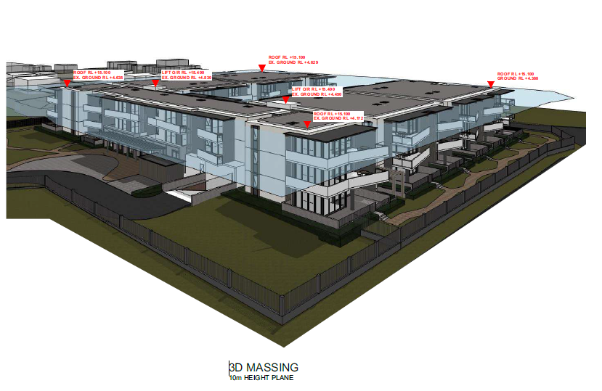

**Figure 3: Building height variation**

Accordingly, a clause 4.6 written variation has been submitted with the application outlining the development standard is considered unreasonable and the development displays sufficient environmental planning grounds to warrant contravention of the development standard. Specifically:

* The proposal seeks to provide a high-quality, purpose-built seniors housing development that displays strong adherence to industry standards and design constraints.

The design of the new building is well-considered and appropriate in terms of its architectural form. Building orientation and form, roof form, materials and finishes, and placement integrate the building and will present a high quality/high amenity and cohesive outcome for the site and surrounds and provides a high-quality urban form as required by the objectives of clause 4.3.

* When viewed from adjoining areas, the new building will not present an overbearing bulk and scale as the site is separated from and screened by vegetation from view from the adjoining residential area south of the site, and the development provides a quality appearance to the adjoining residential care facility and sporting precinct.
* The development does not introduce visual privacy impacts to adjoining lands, particularly the adjoining residential care facility.
* The development does not have adverse overshadowing impacts, particularly concerning vegetation to be retained on the site, and the adjoining residence and residential care facility.
* The floor level is constrained by localised stormwater flow path and the development responds to the site-specific stormwater constraints in setting its floor level.
* The roof height flows on from this restriction. The development achieves three stories above ground, which is consistent with the strategic intent of the building height standard for the site and it surrounding context.
* The outcome achieves the strategic objective of providing housing density in appropriate locations, whereas a development with strict conformity to the height limit would be unable to achieve.
* The height variation is less than 10% and is considered minor.

The proposed variation is considered acceptable for the reasons detailed above.

The building provides a building height that facilitates the function of the development, whilst not having adverse impacts on surrounding lands and users. The building is of a high-quality urban form, as highlighted by Council’s DRP, and is consistent with the objectives of the height of building LEP provisions. Further, the height is consistent with the anticipated development on adjoining and nearby land.

* 1. **Streetscape, building bulk and interface outcomes**

The development provides appropriate streetscape, building bulk and interface outcomes.

The scale of the building adds prominence to the sporting precinct by considering this an important outlook, rather than ‘turning its back’ on the adjacent site. The architecture is well articulated, with appropriate material selection to break up the building mass. This is complemented by landscaping, including appropriately sized trees.

It is acknowledged a Panel briefing was conducted to review the interface outcomes of the development, particularly regarding the western interface with the sports fields.

The eastern wing of the development will be located over the former club carpark, bringing building mass and private open space closer to the eastern boundary.

Setbacks achieved by the development are between 5.7m-9.65m for the ground floor terraces, 7.81m-11.75m for the upper floor balconies, and 9m-13.7m to the walls of the building. The ground surface is raised 0.6m above the sporting fields, with the terraces a further 0.4m above this level. The intervening space is landscaped with trees and shrubs, and includes a circulation path.

The use of the sports fields adjacent the site is currently the primary baseball field. A narrow spectator/circulation space separates the site boundary from the foul ball territory, with the primary playing surface (diamond and outfield) 25m from the boundary. The Belmont Sports Fields Master Plan intends to relocate the fields further eastward and place a car park adjacent the common boundary. This will increase the separation and buffering between the two uses.

The setbacks achieve the distances recommended by the ADG for achieving privacy to windows and open space. This is further enhanced by the level change and landscaping, which will filter views from the sporting fields. Increasing privacy is balanced by the benefits offered to security of the sporting precinct by passive surveillance from the development.

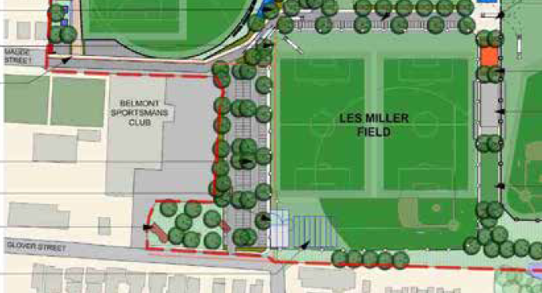

**Figure 4: Belmont Sports Fields Master Plan extract**

The application proposes kerb, gutter and footpath across the southern verge of Maude Street, to Council’s specifications. Street trees cannot be accommodated due to the narrow road reserve. A connection between the kerb and footpath provided by this development and the existing kerb and new footpath provided by the adjacent development will be delivered by Council once the entry feature wall is removed as part of the sporting precinct upgrades.

The Glover Street interface is the primary frontage for this development and includes the entry feature wall with site name, letterboxes and bin store (hidden behind the feature wall). The handle includes substantial landscaping and the building frontage is set almost 50m back from the street and approximately in line with the rear wall of the adjacent residential care facility. This provides a good transition from the residential street.

The Glover Street verge will remain largely as is, with an upgraded site access driveway and new pedestrian connections. A street tree is not considered feasible in this location due to a combination of sight lines and access for services, including the hydrant assembly. Existing mature trees, proposed new trees within the site and the adjacent sports field precinct result in a good streetscape presentation despite not including any trees within the road reserve.

* 1. **Stormwater management**

The development will impact Council stormwater pipes which traverse the site. In particular, removal of a section of pipe draining upstream roads and land will require a new connection through to the outflow. Further, the existing pipe is not located within the existing easement for drainage.

The route of the new pipe was considered in conjunction with the adjacent development, which required augmentation of the pipe capacity as part of their approval. The proposed route locates the new pipe within the existing easement, then takes a new route south of the sporting fields to the existing outflow point. The route has been considered in terms of its potential impact to the use of the sporting fields, and includes consultation with Council’s Assets department. To this end, it is required the route is piped for the full length and no swales used, and construction impacts should avoid the baseball season from March to October. This outcome can be achieved through a condition of consent.

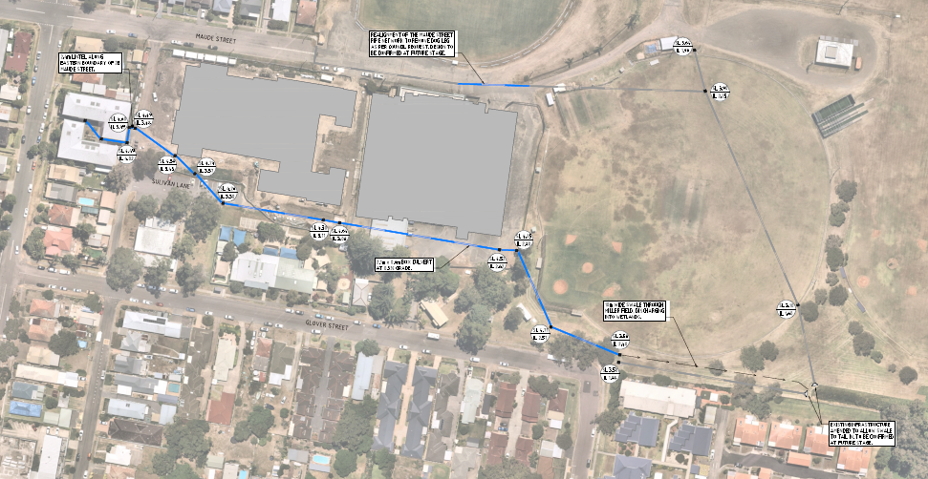

**Figure 4: Proposed Council stormwater pipe, including works on the site under DA and works proposed as future REF**

The portion of the pipe which is a Council asset through public land can be approved via a Review of Environmental Factors under the Transport and Infrastructure SEPP. This will occur following the issue of this consent. Both this and the adjacent development will be liable for delivering the same, coordinated, stormwater outcome independently (notwithstanding they may work together).

An assessment of the potential heritage and ecological impacts has been undertaken for the proposed route and identified the impacts to be minimal, thus providing certainty under this Part 4 assessment of the potential environmental impacts of these works. The new route will result in the removal of several existing Casuarina trees. The trees were not considered to have significant ecological value, and some of the impacted trees were contemplated for removal under the Belmont Sports Fields Master Plan irrespective of this development.

The stormwater plan has been considered by Council’s Development Engineer and was deemed suitable subject to conditions of consent.

* 1. **Design outcomes**

The development achieves permissibility through the *LMLEP 2014* and not the Seniors SEPP. However, the application was benchmarked against the provisions of the SEPP and was found to be satisfactory. For detailed assessment, refer to Attachment C.

* 1. **Social impact**

The proposal includes vehicle and pedestrian gates to the Glover Street frontage (the main entry to the reception). Council’s Social Planner noted concerns regarding the proposed gate arrangements for the development, indicating there is potential for reduced civic engagement and hindrance for service vehicles.

In addressing this matter, the Glover Street gates will be open during daytime hours and closed overnight, with keyed access for residents only, to provide security to the facility. This is considered to adequately address the balance between free access to the public facing entrance and security for users.

The site is located adjacent a senior citizens centre, a sporting precinct, and close to the Belmont Town Centre. Opportunities to engage with the community outside the site are plentiful and easily accessed.

An operational management plan is recommended, and a condition of consent has been drafted to this effect.

Impacts to the adjoining sites will occur during the construction phase, including the senior citizens centre, a childcare centre and the adjoining residential care facility. Conditions of consent have been proposed for a construction management plan which minimises adverse impacts from the construction works.

* 1. **Impacts from adjoining sports fields**

Due to the proximity of the development to the adjoining sports fields, light spill and noise from the use of the sports fields may impact on internal amenity of the site and has been considered as part of the assessment.

The sports fields include two existing lights; one flood light on the eastern side of the field used for throwing practice, and one small light on the western side (facing away from the development site) for general security lighting. These will have minimal impact on the development.

The sports fields will cease use around 9:00pm, with all persons expected to have departed from the site by around 9:30pm. Lighting and noise generation therefore ceases prior to the night time period at 10pm.

A field lighting upgrade will occur as part of the master plan implementation. This will introduce lighting capable of hosting night time games, but will primarily be used for training (a lower light level). Lighting will be designed to the Australian Standard for sport fields lighting, which includes provisions to minimise light spill outside the target area.

The development is able to mitigate any residual impact through the use of appropriate acoustic controls and block out curtains. Through the implementation of these conditions, and the development of the future masterplan, the development is unlikely to result in an adverse impact or restriction on the use of the fields.

The use of the sports fields is expected to generate some noise. Outside of periods of use, the fields are not a noise source. Once constructed, the car park will generate car noise, which is anticipated to run no later than 9:30pm on training days and within daytime noise restrictions. Noise is not expected to be generated after 10:00pm and sleep disturbance exceedances is not likely. Noise generated prior to 10:00pm is relatively minor due to the source and location of generation, and can be readily mitigated through the use of appropriate building materials. Acoustic fencing may have a minor benefit to the ground floor, but little to no effect for the upper floors. An acoustic fence would have negative outcomes for aesthetics and passive surveillance that are not justified by the minimal benefit it may provide.

1. **CONCLUSION**

This development application has been considered in accordance with the requirements of the EP&A Act and the Regulations as outlined in this report. Following a thorough assessment of the relevant planning controls, issues raised in submissions and the key matters identified in this report, it is considered the application can be supported.

The development gives effect to the additional permitted use for seniors housing applicable to the land. Consideration has been given to interfaces with public land, stormwater management, contamination, building heights, and social impacts, with these matters satisfied (with or without conditions of consent). The development will not impact the use of the adjacent sports fields or sensitive receivers, subject to appropriate construction timing and methodology.

1. **RECOMMENDATION**

Development Application DA/2294/2021 for Seniors Housing at 2A Maude Street, Belmont, be approved subject to the draft conditions of consent attached to this report at Attachment A.